Phase 2 — Requirement Analysis
Technology Stack (Architecture & Stack)
Field | Value
Date | 31 January 2026
Team ID | SWTID-2026-1543
Project Name | Virtual Agent–Driven SLA Breach Awareness & Justification System
Maximum Marks | 4 Marks

Table 1 — Components & Technologies
S.No | Component | Description | Technology
1 | User Interface | How agents interact with the governance workflow | ServiceNow Service Portal / Now Experience UI, Virtual Agent chat widget
2 | Application Logic-1 | SLA risk detection and threshold monitoring | Flow Designer
3 | Application Logic-2 | Conversational acknowledgement & guided remediation | Virtual Agent (Now Assist / VA Designer)
4 | Application Logic-3 | Mandatory field enforcement on breach | UI Policies, Business Rules (declarative)
5 | Database | Core record storage for incidents/tasks, SLA data, work notes | ServiceNow platform tables (Task, Incident, SLA, sys_audit)
6 | Access Control | Role-based read/write restriction on governance fields | Access Control Lists (ACLs), Roles
7 | Notifications | Real-time alerts to assignees/managers | ServiceNow Notifications (Email/Push), Virtual Agent messaging
8 | Reporting & Visualization | SLA trend, breach-rate and accountability views | Performance Analytics, Reports, Dashboards
9 | Infrastructure | Application deployment | Native ServiceNow instance — no external server or cloud dependency

Table 2 — Application Characteristics
S.No | Characteristics | Description | Technology
1 | Declarative / Zero-Code Framework | No custom scripting used anywhere in the solution | Flow Designer, UI Policy, ACL, VA Designer
2 | Security Implementations | Role-based access control on all SLA governance artifacts | ACLs, Roles, sys_audit logging
3 | Scalable Architecture | Configurable thresholds/roles scale across tables and departments | Flow Designer reusable subflows
4 | Availability | Runs natively within the always-on ServiceNow instance | Platform-native, no added infrastructure
5 | Performance | Near real-time detection and alerting design | Flow Designer scheduled/event triggers
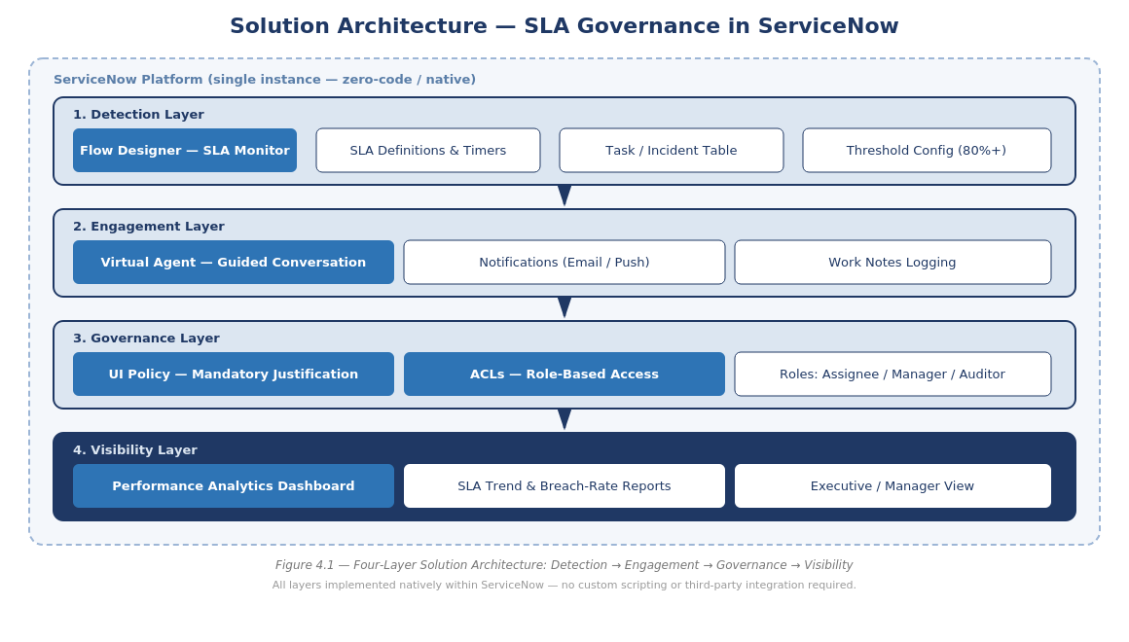
Figure 2.2 — Reference Architecture Diagram Supporting the Technology Stack

Technology Choice Justification
Flow Designer was selected over scripted Business Rules/Script Includes for the SLA monitoring engine because it is fully declarative, version-controllable via Update Sets, and maintainable by admins without developer involvement — directly supporting the project's zero-code goal.
Virtual Agent was selected as the engagement layer instead of a static form or email-only workflow because it converts a passive notification into an interactive, guided conversation, which the Empathy Map identified as a key driver of faster, more consistent agent response.
UI Policies and ACLs were chosen over custom client scripts and ACL scripts because they provide the same enforcement guarantees (mandatory fields, restricted access) while remaining fully declarative and auditable through the platform's native configuration history.
No external database, cloud service, or third-party integration is used: all data remains within the ServiceNow platform's native tables, minimizing security surface area and eliminating integration maintenance overhead.

